March 25, 2008

Edward Adelson
Associate Executive Dean
Colleges of the Arts and Sciences
114 University Hall
230 N Oval Mall
CAMPUS

Dear Ed,

The College of the Arts Curriculum Committee has reviewed and voted unanimously to support the Department of Dance’s proposal to revise the undergraduate Bachelor of Fine Arts (a tagged degree approved by OAA in May of 1990) major program. We discussed the proposal with Professor John Giffin, Chair of Undergraduate Studies in the Department of Dance, during our ARTS CC deliberations on Monday, February 11, 2008, and we were pleased to unanimously support the Department of Dance’s changes to the B.F.A.

The proposal was vetted and supported by the full faculty in the department, designed in close consultation with the Arts Advising Staff and Cluster Coordinator Tracy Tupman, and went through two revisions with the Arts CC. The revisions are reflective of the field, the historic strengths of the department, the accrediting body of the National Association of Schools of Dance (NASD), and the shift in focus to place the student at the center of his or her learning and as an active participant in guiding his or her curricular program.

The tagged degree is currently 191 credit hours, with 60 in the General Education Curriculum and 131 in the major program. These will remain unchanged. The primary changes are described below:

- GEC reflects the revised GEC with the new areas added, reducing Social Science from 15 to 10 credit hours, and placing 5 of those credit hours in the Additional Breadth category.

- The Advising Colloquiums, created in a seminar-type format, facilitate student and faculty contact, with students meeting in small groups, typically 10, with three tenure-track faculty three Fridays each quarter over the course of two years. In these colloquiums faculty and students create the proposals for senior projects, discuss current creative projects, provide feedback on processes, and advise. These newly proposed courses are included as appendices to the proposal.

- Major Technique hours of 48 remain the same. 65 hours from the old “Dance Course” column, 17 free electives, and 1 credit in dance survey (83 hours) move to a more focused division of 2 in Advising Colloquiums, 51 in Foundation Curriculum, and 30 in Contract Curriculum (total 83 hours). This division provides room for a student to focus on a particular aspect of dance, or to include 10 hours outside the department from another department, or even to count those hours toward a minor! These changes reflect the interdisciplinary nature of the arts and the humanistic nature of the art-making process.

The department is currently piloting in the new major program with its freshman class and current sophomores. The department, along with the Arts Advising (Arts and Sciences Advising) staff, foresees no problems in having current juniors and seniors finishing the “old” program requirements while implementing the “new” program requirements.

We thank you in advance for moving this proposal through the next appropriate steps, and look forward to its ultimate approval and implementation for fall of 2008. If you have questions about the proposal please feel free to contact me at 292-5171 or through email, mockabee.1415.

Thank you,
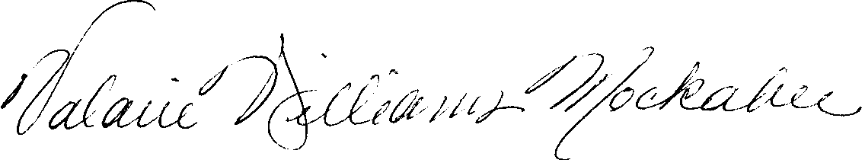
Valarie Williams Mockabee
Associate Dean, College of the Arts

cc: John Giffin, Undergraduate Chair, Department of Dance
ARTS CC

